MATH STUDENT RESPONSE SHEET

Score
Name of Open Response: Interpreting Plant Growth Student Name _____________________
Type of Response: Algebraic Ideas
The equations below show the growth of two plants, with x representing the growing time in weeks and y representing the height of the plants in inches.
Plant 1: y = 1x + 3
Plant 2: y = 3x + 3
- Using the grid, graph each of the above equations.
- Find the point of intersections of the graph of the two equations and explain what the graphs tell you about the growth of teach to the two plants. Include in your explanation a description of the significance of both the y-coordinate of the intersection and the slopes of the graphs of the equations form Plant 1 and Plant 2.
- Algebraically solve the system of equations.
Scoring Guide for “Interpreting Plant Growth”

Score | Description
4 | Student scores 6 points.
3 | Student scores 4 or 5 points.
2 | Student scores 2 or 3 points.  OR  Student shows an ability to perform some correct procedure(s) in two or three parts
1 | Student scores 1 point.  OR  Student shows some understanding of how to graph an equation or how to interpret the graph of an equation or how to interpret linear equations.
0 | Response is totally incorrect or irrelevant.
Blank | No Reponse.

Part a 2 points for correct graph for both equations y = 1x + 3, y = 3x + 3
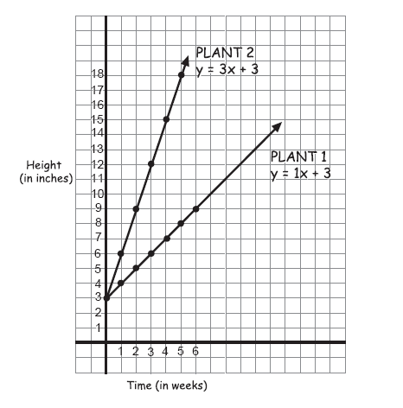
(with correctly labeled axes: y axis = height, x axis = time)

1 point for correct graph for both equations without axes labeled
1 point for correct graph for on equation (with or without axes labeled)
Part b 1 point names correct coordinates of the point of intersections (0,3)
1 point gives appropriate description of y-coordinate of intersection-both planets were three inches tall or both plants were the same height
1 point gives appropriate description of slope-describes the rate of growth. Plant 1 grows one inch per week; Plant grows three inches per week Plant 2 grows three times as fast as plant 1.
Part c 1 point for correct algebraic solution
(0,3)
Plant 1 y = x + 3 Plant 2 y = 3x + 3
(3x + 3) = x + 3 y = 3(0) + 3
2x + 3 = 3 y = 3
2x = 0
X = 0

